**Alpha Wisdom Vidhyashram**



**Computer Science**

A Project on

Inventory management

Submitted by:  
Harish Santosh

XII-E

**ACKNOWLEDGEMENT**

In the accomplishment of this project successfully, many people have best owned upon me their blessings and the pledge support, I’m utilizing this time to thank all the people who have been concerned with this project.

Primarily I would thank god for making me being able to complete this project with success. Then I would like to thank my Principal **Mr. Henry David** and my, Computer science teacher **Mrs.B.Kavitha** whose valuable guidance has been the ones that helped me patch this project and make it a full proof success. Her suggestions and her instruction have served as the major contribution towards the completion of this project

Then I would like to thank my parents who have helped me with their valuable suggestions and guidance that has been very helpful in various phases of the completion of this project.

Last but not the least I would like to thank my classmates who have helped me a lot.

**Content**

|  |  |  |
| --- | --- | --- |
| S.no | Title | Page.no |
| 1. | Project synopsis |  |
| 2. | System requirements |  |
| 3. | Database design |  |
| 4. | User manual |  |
| 5. | Limitations |  |
| 6. | Conclusion |  |
| 7. | Bibliography |  |

**Project Synopsis**

The Inventory Management Database project aims to streamline and optimize inventory control processes for a retail business by developing a comprehensive database system. This system will efficiently record and track product information, including item descriptions, stock quantities, supplier details and pricing. Additionally, it will provide features for generating real-time inventory reports, managing reorder points, and automating purchase orders. By centralizing and automating these critical aspects of inventory management.

The main objective of this project is to enhance operational efficiency, minimize stockouts, reduce excess inventory, and ultimately improve the overall profitability and customer satisfaction of the business.

**SYSTEM REQUIREMENTS**

**HARDWARE USED:**

While developing the system, the used hardware are:

* Intel(R) Core(TM) i3-3120M CPU @ 2.50GHz
* RAM : 4.00 GB
* 64-Bit operating system
* Operating system : windows 10 pro
* Graphics: Intel HD graphics 4000
* Standard I/O devices like keyboard and mouse, etc.

**SOFTWARE USED:**

* + Microsoft Windows 10 Pro as OS.
  + Python version 3.10 as Front-end server.
  + MySQL as Back-end Server with Database.
  + MS-Word 2007 for Documentation.

**Database Design**

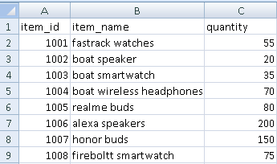

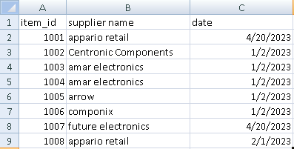

**USER MANUAL**

**DATABASE INSTALLATION:**

* The software project is distributed with a backup copy of a database named school with required tables. Some duplicate records are present in the tables for testing purposes, which can be deleted before inserting real data the is shipped with SCL.SQL file which installs a database and tables in the computer system.
* NOTE: The PC must have MySQL server with user (root) and password (root). If root password is any other password, it can be changed by running MySQL server instance and configure wizard.
* Start → Program →MySQL → MySQL Server → MySQL Server Instance Configure Wizard.
* Provide current password of root and new password as “root”, this will change the root password.
* To install a MySQL database from a dump files (SCL.SQL),simply follow the following steps:

1. STEP1: Copy the Lib.sql file in C:\Program files\MySQL\MySQL Server 5.1\Bin folder.
2. STEP2: Open MySQL and type the following command to create the database named library.
3. MySQL🡪create Database School;
4. STEP3: Open command window (start🡪 run 🡪cmd).
5. STEP4:Go to the following folder using CD command of DOS.
6. C:\Program files\MySQL\MySQL server 5.1\Bin>
7. Step 5: type the following command on above prompt –
8. C:…..\bin> MySQL –u root –p kvuc School <Scl.sql

* This will create a Library database with required tables.

**Limitations**

* Lack of real time data
* Training: employees may need training to learn to use database effectively
* The accuracy of data depends mainly on manual entry

**Conclusion**

The Inventory management system is user friendly software which manages the important data of various products in the store. The software helps in effective management of the appliance store. It allows the user to add, search, view and store the records of appliances. The main purpose of the project is effective and easy handling of data.

**Bibliography**

* [www.slideshare.net](http://www.slideshare.net)
* xiipython.blogspot.com
* www.cs4school.com/cbse/python-project-for-class-12